Healthcare Resource Priorities
Executive assessment of the 2025 National Health Interview Survey
Kelly Emrick, DHSc, PhD, MBA, BSRT(ARRT)R | September 27, 2026

Executive summary
Recommendation: Direct the next increment of discretionary resources toward accessible outpatient chronic disease management, integrated behavioral health, function-oriented pain care, and assistance that helps patients complete treatment. Begin with a measured operating pilot and require local demand and financial evidence before committing to major capital expansion.
The national burden is substantial: 27.8% of adults reported diagnosed hypertension, 20.8% regularly experienced chronic pain, and 12.5% regularly experienced anxiety-related feelings. Cost prevented needed medical care for 6.0% and needed mental health care for 5.4%. Among prescription users, 7.5% altered medication use to save money. These are overlapping populations, not additive market segments (Norris et al., 2026a).
This assessment assumes a general adult-serving hospital or multispecialty facility. An imaging-specific application appears on page 4. National prevalence establishes a reason to investigate and pilot services; it does not establish local referral demand, staffing requirements, reimbursement, or return on investment.

Proposed allocation of new improvement resources
Table 1. Illustrative management allocation per $100 of a new discretionary operating improvement fund. These shares are recommendations, not NHIS findings or an optimized budget. Existing essential services remain funded through the base budget.
Priority | Share | Initial use of resources
Primary care and hypertension | 30% | Nurse or pharmacist follow-up, medication review, home BP support, protected access
Integrated behavioral health | 20% | Care management, psychiatric consultation, brief therapy and completed follow-up
Pain and physical function | 20% | Conservative care pathways, rehabilitation access and function measurement
Affordability and care navigation | 20% | Benefit and medication assistance, cost estimates, transport and referral completion
Prevention and community links | 10% | Vaccination outreach, tobacco treatment connections and dental partnerships
Authorize a 90-day pilot within a capped local budget. At day 30, reset this allocation using actual unmet need, wait times, staffing capacity and unit economics. At day 90, decide whether to expand, redesign or stop each component. Clinical outcomes and total cost effects require longer follow-up.

What the data mean for service lines
Figure 1. Selected national health burdens among adults aged 18 and older in 2025
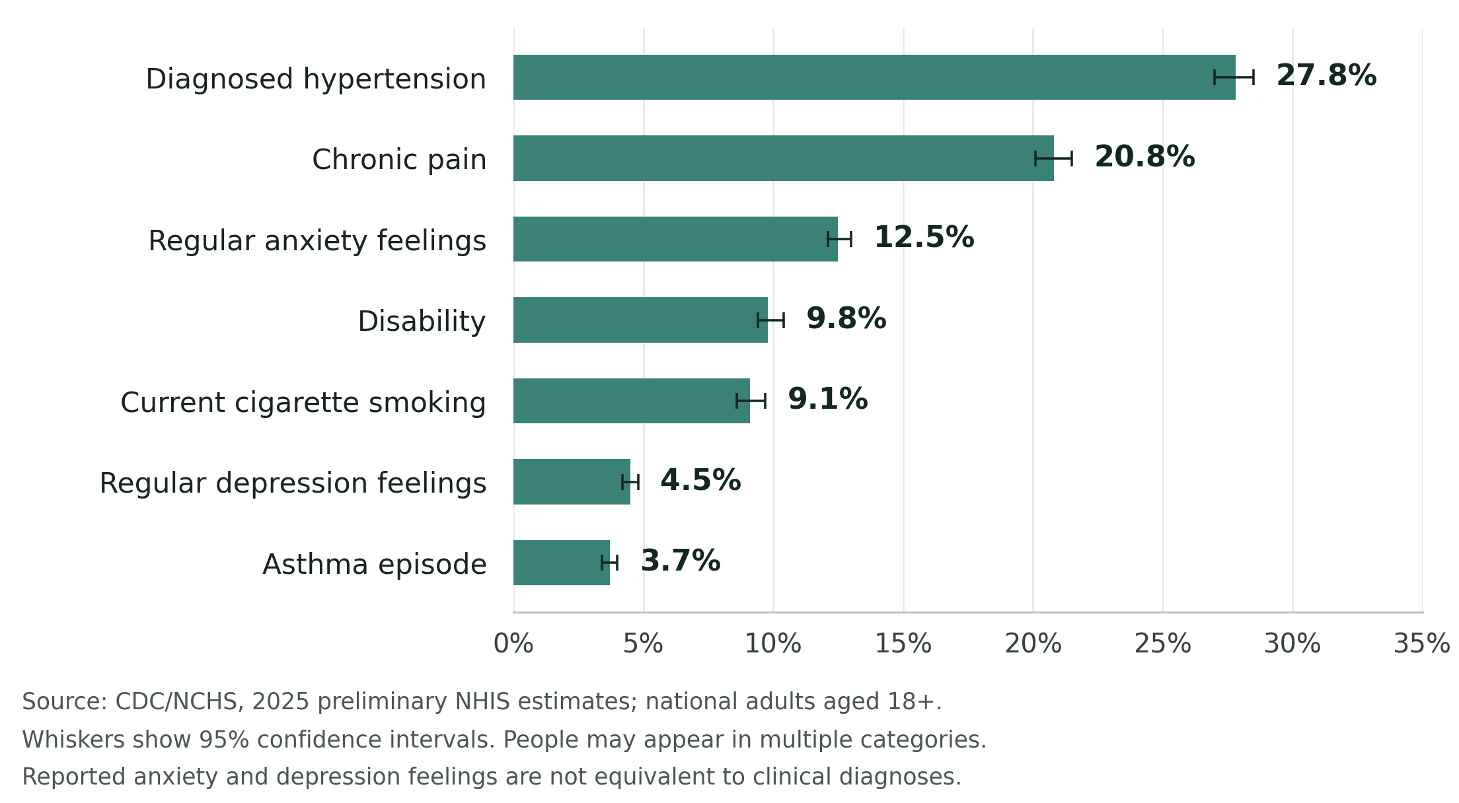

Primary care and cardiovascular prevention
Hypertension deserves the largest initial share because the burden is high and the treatment infrastructure can support other chronic conditions. The 87.5% who reported a recent BP check cannot be interpreted as having controlled BP. Build reliable follow-up, medication adjustment and adherence support around the measurement. A 2025 meta-analysis found pharmacist care lowered systolic BP by about 5.3 mmHg relative to controls, with substantial variation between studies (Gastens et al., 2025). This supports a staffed management pathway; it does not establish local savings.

Behavioral health and chronic pain
Use primary care as an entry point for behavioral health, with a care manager and consultant psychiatrist or contracted partner. Track treatment initiation and symptom change. Collaborative depression care has recent trial-based support, although average effects are modest (Schillok et al., 2025). Anxiety and depression figures in NHIS are symptom constructs; neither is a count of diagnosed disorders or a ready-made treatment waiting list.
Chronic pain supports investment in assessment, conservative treatment and physical function. Coordinate rehabilitation and behavioral support according to clinical need. The SPACE trial found opioids were not superior to nonopioid medication strategies for pain-related function in its study population (Krebs et al., 2018). The 20.8% estimate provides no basis for assuming that these adults require MRI, injections or surgery.

A practical population health operating plan
Create one patient registry with overlapping clinical and access flags. Assign a single accountable care coordinator for patients with multiple needs. Prioritize uncontrolled disease, recent acute care use, interrupted treatment and functional limitations. Include patients with cancelled or incomplete referrals so the program does not become limited to people who already navigate care successfully.
Use ZIP code, age, payer, preferred language, disability accommodations and transportation or cost barriers to inspect differences in access and completion. Base outreach intensity on clinical need and demonstrated barriers. Maintain telephone and in-person options alongside digital tools. Community organizations, pharmacies, rehabilitation providers and dental partners can supply capacity without requiring the facility to own every service.
Table 2. Proposed implementation responsibilities and evidence required for review. Owners are suggested roles; timing starts when the pilot is approved.
Timing and owner | Action | Decision evidence
Days 1 to 30  COO and analyst | Define service area; review 12 months of visits, claims, waits, referrals and missed care; interview patients. | Baseline counts, denominator definitions, capacity and cost per completed episode
Days 31 to 60  Primary care and pharmacy leads | Start a hypertension cohort with repeat BP measurement, medication review and follow-up. | BP control using an agreed clinical definition; missing measurements; medication access
Days 31 to 60  Behavioral health lead | Embed or contract care management and consultation; reserve treatment appointments. | Time to first completed visit; treatment initiation; symptom change at follow-up
Days 31 to 90  Rehabilitation and pain leads | Test a function-oriented pathway with reliable reassessment. | Change in a consistent validated function measure; completion; adverse events
Days 31 to 90  Access and revenue cycle leads | Resolve cost, coverage, transport and scheduling barriers; close referrals. | Barrier resolution; referral-to-completion time; cancellations; patient expense
Day 90  Executive sponsor and CFO | Compare pilot results, capacity and actual spending with baseline. | Continue, modify or stop; plan six-month clinical and financial review

Measure outcomes and the ability to deliver care
Use a defined cohort at baseline and follow-up; report missing outcomes. Track BP control and missing BP measurements, behavioral health access and symptom change, and pain-related function. For vaccination, distinguish eligible patients with documented receipt, unknown status, contraindications and refusal.
Proposed process goal: document follow-up outcomes for at least 80% of pilot enrollees by their review date. This is not a national benchmark. Set clinical targets after baseline review; monitor workload, overtime and patient expense.

Financial decisions and the imaging application

Require a service level business case
Translate population need into a realistic service forecast: locally eligible patients multiplied by documented unmet need, expected acceptance and completion, and the number of clinically appropriate encounters. Account for existing provider capacity and competing services. Prevalence alone omits every one of these conversion steps.
For fee-for-service programs, estimate collectible revenue by payer and subtract labor, supplies, contracted services and incremental overhead. For risk-based contracts, separately estimate the share of any verified savings the organization can retain. Avoided emergency visits may benefit patients and payers without producing equivalent facility revenue. Report patient benefit, operational performance and financial contribution separately.
Affordability assistance should be integrated with clinical follow-up. In the ARTEMIS trial, copayment vouchers modestly improved medication persistence after myocardial infarction but did not significantly improve one-year major cardiovascular outcomes (Wang et al., 2019). Therefore, do not book assumed admission savings from financial assistance before measuring them locally.

Application to an outpatient MRI facility
For a facility such as KCAI, the highest immediate value is likely to come from completing clinically indicated studies and closing the diagnostic loop. Prioritize benefits verification, authorization support, understandable cost estimates, cancellation recovery, accessible appointments and communication of results to the ordering clinician. Track the reasons patients fail to reach or complete a scan.
Build referral relationships with primary care, orthopedics, neurology and rehabilitation around appropriate clinical pathways. Chronic pain prevalence is a reason to understand referral needs, not to promote imaging for every patient with pain. Capture the clinical indication, referral date, authorization milestones, scheduled date, exam completion, report availability and acknowledgement when follow-up is required.
Before buying another scanner or expanding a modality, require evidence of sustained appropriate backlog, utilization by time of day, payer-specific collections, staffing feasibility and positive incremental economics under conservative volume assumptions. Test extended hours or workflow changes where feasible. Hypertension, mental health and smoking needs can be addressed through referral partnerships and safe escalation protocols without turning an imaging center into a comprehensive primary care practice.

Where to defer or use partnerships first
The sheet does not justify new inpatient beds, emergency department expansion or specialty equipment. Address asthma, smoking, vaccination and dental access through existing services and partnerships first. Oncology, maternity, diabetes, obesity and pediatric priorities require other evidence; these indicators cannot rank them.

Complete national indicator reference
Table 3. January through December 2025 estimates and published 95% confidence intervals. Percentages are unadjusted and refer to people, not encounter volume. Source: Norris et al. (2026a).
Indicator | Percent | 95% CI
Disability status | 9.8 | 9.4 to 10.4
Six or more workdays missed for health reasons [1] | 12.8 | 12.2 to 13.5
Asthma episode in past 12 months | 3.7 | 3.4 to 4.0
Diagnosed hypertension | 27.8 | 27.0 to 28.5
Chronic pain on most days or every day | 20.8 | 20.1 to 21.5
Regular anxiety related feelings | 12.5 | 12.1 to 13.0
Regular depression feelings | 4.5 | 4.2 to 4.8
Doctor visit in past 12 months | 84.9 | 84.2 to 85.6
Any emergency department visit in past 12 months | 20.9 | 20.2 to 21.5
Mental health counseling in past 12 months [3] | 13.4 | 12.1 to 13.9
Blood pressure check in past 12 months | 87.5 | 86.9 to 88.1
Dental exam or cleaning in past 12 months | 66.7 | 65.6 to 67.8
Influenza vaccination in past 12 months | 41.8 | 40.8 to 42.8
Needed medical care not obtained due to cost | 6.0 | 5.6 to 6.4
Needed mental health care not obtained due to cost | 5.4 | 5.0 to 5.8
Medication not taken as prescribed to save money [2] | 7.5 | 7.1 to 7.9
Uninsured at interview [4] | 11.6 | 10.9 to 12.3
Private health insurance at interview [4] | 69.4 | 68.3 to 70.5
Public health coverage at interview [4] | 21.0 | 20.2 to 21.9
Exchange based coverage at interview [4] | 7.1 | 6.6 to 7.7
Current cigarette smoking | 9.1 | 8.6 to 9.7
Current electronic cigarette use | 6.7 | 6.2 to 7.2
[1] Adults with qualifying employment in the prior week or past year. [2] Adults who used prescription medication in the past year. [3] Counseling interval reproduced as published; its unusual asymmetry should be verified before interval-based inference. [4] Ages 18 to 64. All other rows describe adults 18 and older.
Private and public insurance overlap. Exchange plans are included within private insurance. Symptoms, disability, smoking and service use also overlap across individuals. Do not add these percentages or subtract counseling from symptom prevalence to estimate untreated illness.

Interpretation limits and evidence
The attachment is a preliminary national household survey release, not a local utilization or revenue study. The 2025 adult sample included 24,208 people. NCHS reports a late-year fieldwork interruption, an unfielded December sample with weight adjustments, and a new sample design. The civilian noninstitutionalized population excludes important groups such as nursing home residents (Norris et al., 2026b).
Use the annual column for planning. The half-year columns identify interview periods, while many questions ask about the preceding 12 months. Their modest numerical differences are not proof of significant trends. The 27.8% hypertension figure concerns diagnosed disease rather than measured or controlled BP; the flu measure is not season-specific. The 20.9% emergency department figure does not identify avoidable visits. Local subgroup demand and intervention savings remain unmeasured.

Sources and selected peer reviewed references
Gastens, V., Tancredi, S., Kiszio, B., Del Giovane, C., Tsuyuki, R. T., Paradis, G., Chiolero, A., & Santschi, V. (2025). Pharmacists delivering hypertension care services: A systematic review and meta-analysis of randomized controlled trials. Frontiers in Cardiovascular Medicine, 12, 1477729. https://doi.org/10.3389/fcvm.2025.1477729
Krebs, E. E., Gravely, A., Nugent, S., Jensen, A. C., DeRonne, B., Goldsmith, E. S., Kroenke, K., Bair, M. J., & Noorbaloochi, S. (2018). Effect of opioid vs nonopioid medications on pain-related function in patients with chronic back pain or hip or knee osteoarthritis pain: The SPACE randomized clinical trial. JAMA, 319(9), 872–882. https://doi.org/10.1001/jama.2018.0899
National Center for Health Statistics. (2026). 2025 NHIS preliminary microdata file codebook report, quarters 3 and 4 (pp. 54, 73). https://www.cdc.gov/nchs/data/nhis/earlyrelease/2025-Q3Q4prelim-nfcodebook.pdf
Norris, T., Bottoms-McClain, L., & Adjaye-Gbewonyo, D. (2026a). Early release of selected estimates based on data from the 2025 National Health Interview Survey. National Center for Health Statistics. User-supplied two-page data sheet. https://www.cdc.gov/nchs/data/nhis/earlyrelease/Early-Release-of-Selected-Estimates-Based-on-Data-from-the-2025.pdf
Norris, T., Bottoms-McClain, L., & Adjaye-Gbewonyo, D. (2026b). Technical notes for early release of selected estimates based on data from the National Health Interview Survey. National Center for Health Statistics. https://www.cdc.gov/nchs/data/nhis/earlyrelease/earlyrelease202605-tech.pdf
Schillok, H., Gensichen, J., Panagioti, M., Gunn, J., Junker, L., Lukaschek, K., Jung-Sievers, C., Sterner, P., Kaupe, L., Dreischulte, T., Ali, M. K., Aragonès, E., Bekelman, D. B., Herbeck Belnap, B., Carney, R. M., Chwastiak, L. A., Coventry, P. A., Davidson, K. W., Ekstrand, M. L., ... Bühner, M. (2025). Effective components of collaborative care for depression in primary care: An individual participant data meta-analysis. JAMA Psychiatry, 82(9), 868–876. https://doi.org/10.1001/jamapsychiatry.2025.0183
Wang, T. Y., Kaltenbach, L. A., Cannon, C. P., Fonarow, G. C., Choudhry, N. K., Henry, T. D., Cohen, D. J., Bhandary, D., Khan, N. D., Anstrom, K. J., & Peterson, E. D. (2019). Effect of medication co-payment vouchers on P2Y12 inhibitor use and major adverse cardiovascular events among patients with myocardial infarction: The ARTEMIS randomized clinical trial. JAMA, 321(1), 44–55. https://doi.org/10.1001/jama.2018.19791

